**Experiment 02**

**Aim:** Use basic networking commands in Linux (ping, tracert, nslookup, netstat, ARP, RARP, ip, ifconfig, dig, route )

**Commands and Output:**

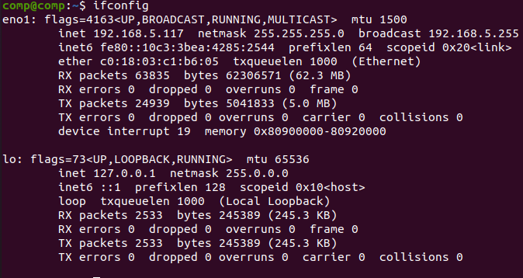

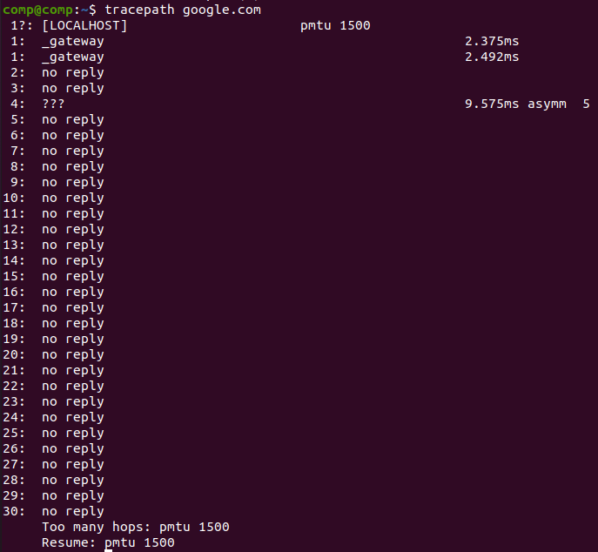

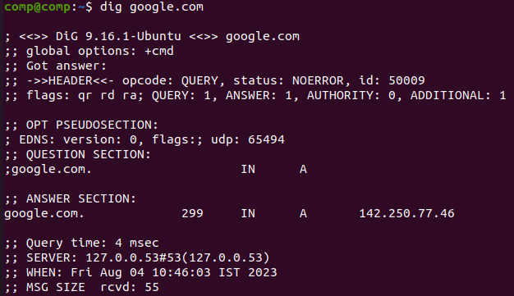

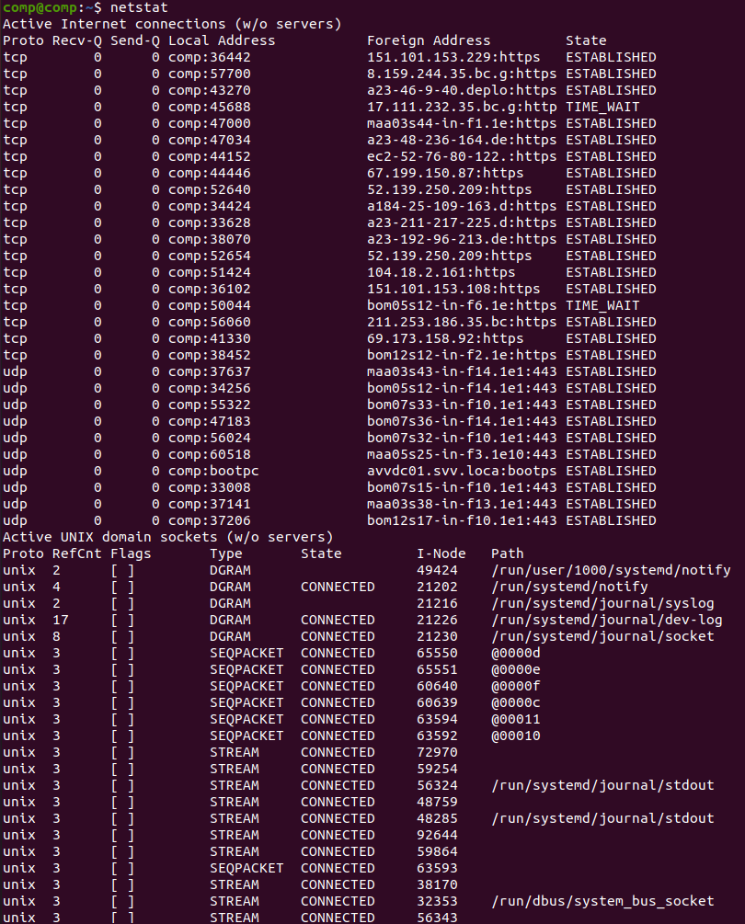

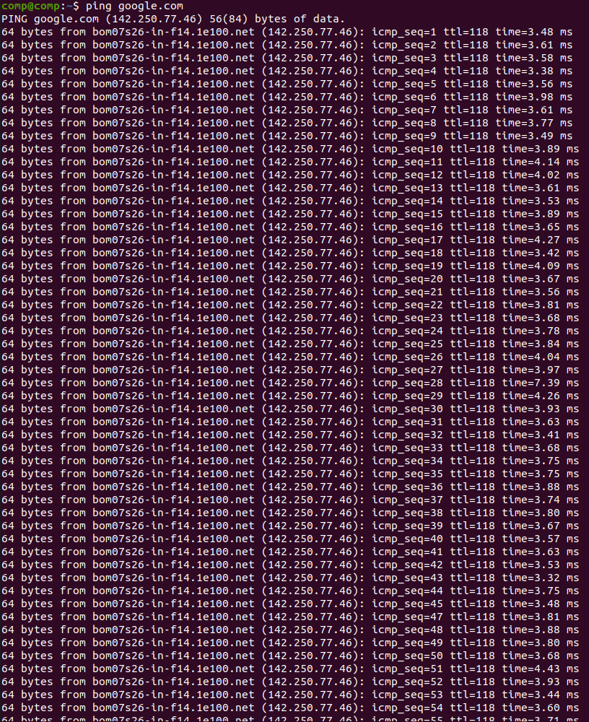

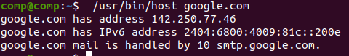

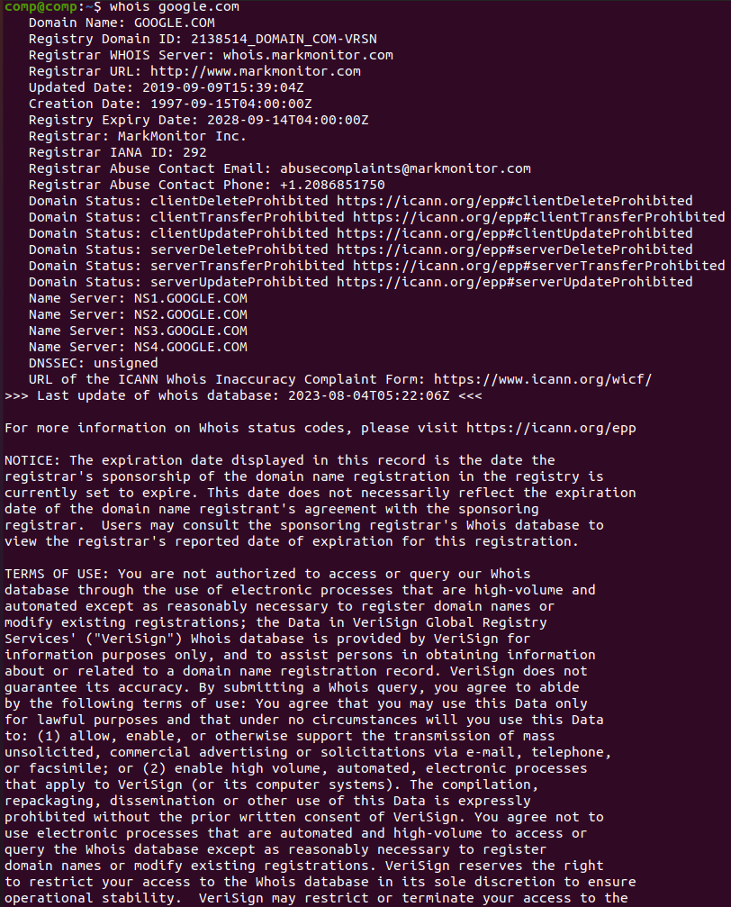

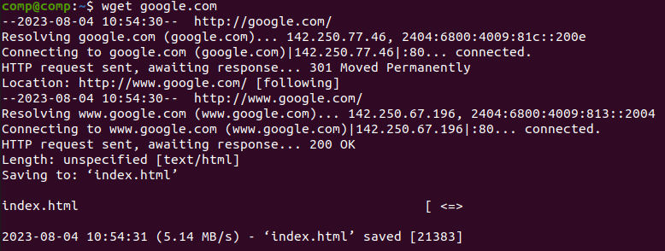

**Conclusion:** In this experiment, we used various basic networking commands in Linux to gain insights into network connectivity and configurations. These commands are valuable tools for network administrators and users to diagnose and troubleshoot network issues, check DNS resolution, view network statistics, manage network interfaces, and analyze routing information. Understanding these commands is essential for efficient network management and troubleshooting.